**DAILY REPORT**

**Student Name :SINDHU.N**

**Class and Sec : VI B**

**USN :4AL17CS094**

**DATE:09-07-2020**

|  |  |  |  |  |
| --- | --- | --- | --- | --- |
| **Online Test Details** | | | | |
| **Subject** | **-------** | | | |
| **Semester** | **VI -B** | | **Duration** | **------** |
| **% of marks** | | **----** | | |

|  |  |  |  |
| --- | --- | --- | --- |
| **Certification Course Details** | | | |
| **Course** | SSCD(9.45 to 11.00am)  Python Data Structure | | |
| **Certificate Provider** | coursera | **Duration** | 19hours |

**Snapshots of the daily class acitivities .**

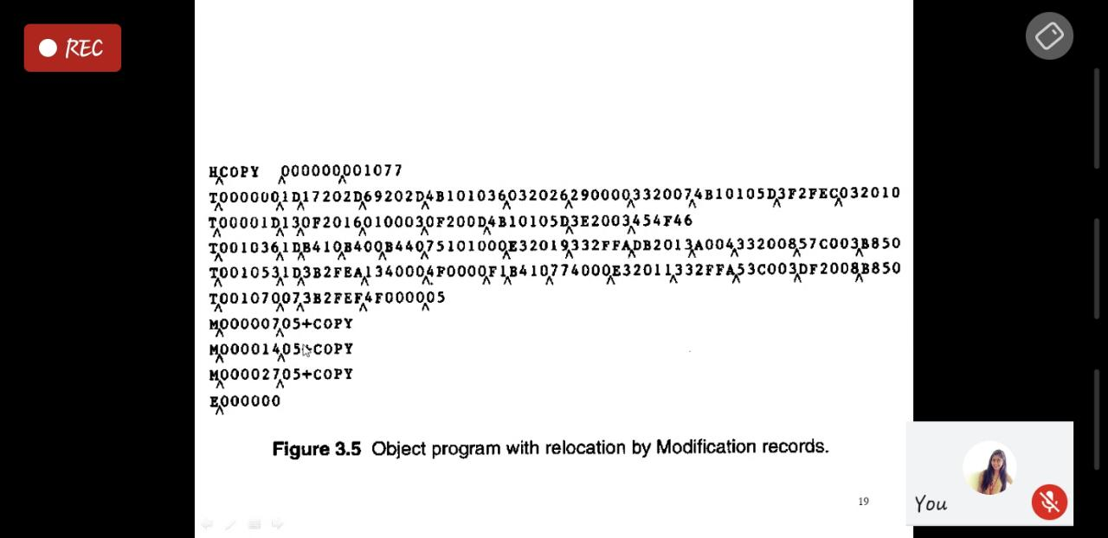

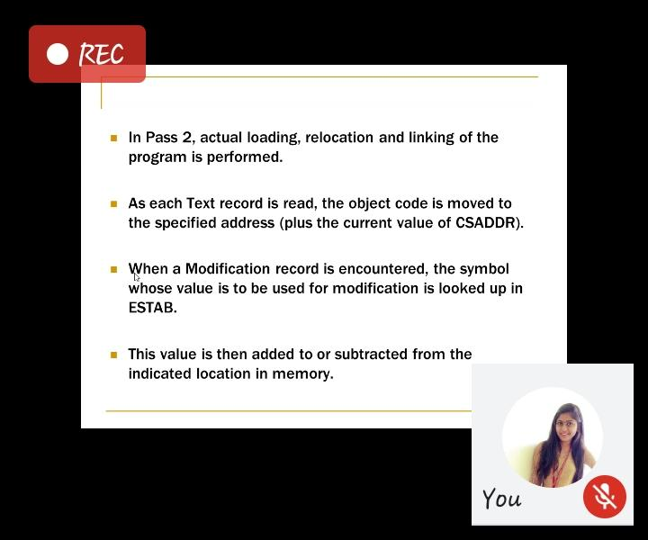

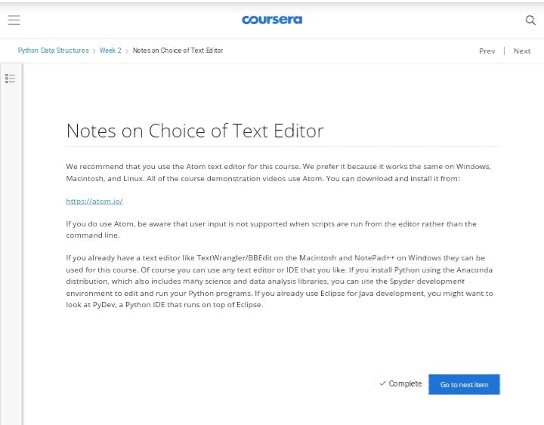

|  |  |
| --- | --- |
| **Coding Challenges** | |
| **Problem Statement: 1.Python Program for Find largest prime factor of a number.** | |
| **Status:** Executed | |
| **Uploaded the report both in Github & Slack** | Yes |

**Snapshots of your response to challenge.**

1. ****Python Program for Find largest prime factor of a number.****

**import math**

**def maxPrimeFactors (n):**

**maxPrime = -1**

**while n % 2 == 0:**

**maxPrime = 2**

**n >>= 1 # equivalent to n /= 2**

**for i in range(3, int(math.sqrt(n)) + 1, 2):**

**while n % i == 0:**

**maxPrime = i**

**n = n / i**

**if n > 2:**

**maxPrime = n**

**return int(maxPrime)**

**# Driver code to test above function**

**n = 15**

**print(maxPrimeFactors(n))**

**n = 25698751364526**

**print(maxPrimeFactors(n))**

****OUTPUT****

